Task Analysis

This means that each turn, coin, and length in the maze should be counted to be used to generate the percentages when the ant completes its journey.

Nested if statements were not used as it makes the code nicer to read. Reiterates the fact that the maze changes between tests.

The main task which needs to be completed, is simple to interoperate

The image of the maze is very useful and gives many parameters not explicitly stated in the task. These include:

* There is only one path to the end of the maze
* The specific shape of the entrance to the maze

Gives Context for task. Has little use for completing the task.

Gives further detail for the tasks. Given the maze changes during each attempt, static code to complete a single maze cannot be used. The unknown amount of turns or length doesn’t really affect the final code.

Activity 5

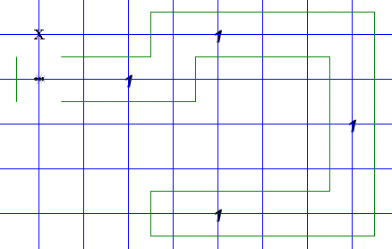

You are at Maze City and dollar coins (markers) have been dropped randomly throughout the maze. There is no accurate map of the maze as it can be changed from day to day. It is unknown what the length of the maze is or how many twists and turns it makes.

**Question 5**

You are to program Robo to enter the maze and find all the money and return it to the entrance.

[Hint! You will need to use nested IF statements in your solution.]

[Ensure your program works for coins in all possible positions in the maze, and also ensure your program will work for a maze that twists and turns randomly]

**Challenge**

* Display the number of coins as a percentage of the number of turns in the tunnel
* Display the number of turns as a percentage of the length of the tunnel

Mind Map

Criteria

Develop

|  |  |
| --- | --- |
| Start:  Both left and right of the ant are clear initially which will break navigation loop so an initial move is used | Main function:  Every tick the ant scans its surroundings and determines whether it is standing on a coin and if so, pick it up then checks the direction of the next valid square and moves in that direction. This process repeats until it has reached a square where no forward tiles are valid |
| Once it has been determined that the ant has reached the end of the maze it turns around | Once the ant has returned to the entrance it simply drops all of its collected tokens |

Algorithm

Code

Evaluation